ADA Open Ended Project Report on

AIRLINE RESERVATION SYSTEM

Submitted By : Ishita Saxena (1SI19CS051)

BATCH :B1



DEPARTMENT OF COMPUTER SCIENCE AND ENGINEERING

SIDDAGANGA INSTITUTE OF TECHNOLOGY, TUMKUR-572103

(An Autonomous Institute, Affiliated to Visvesvaraya Technological University, Belgaum, Recognized by AICTE and Accredited by NBA, New Delhi)

2020-2021

Problem statement:

In Airline reservation system, Passengers generally has two prefrences while booking flight tickets. Sometimes it become difficult to find the flight which is cost efficient or time efficient.
Our project is based on this, here we give two options one for cost efficient and second for time efficient. Passengers can choose anyone of them and can book flight tickets.The program will show the shortest path between source and destination city according to the prefrence the user choose.

First there will be 3 options:
1.Cities we travel.
2.Book your flight.
3.Print your ticket.

Here passengers can search for the flight as per their requirements and book the flight. Then there will be an option to print the ticket, they can print it easily.

Abstract:

According to the problem statement, let’s solve the problem by taking an example. Let say there are some cities (“Mumbai","Kolkata","Banglore","Delhi","Lucknow","Chennai","Pune","Ahemdabad","Hyderabad","Chandigarh"). We want to book flight from one city to another. While booking a flight it will ask for the prefrence of the cost efficient flight and the time efficient flight. It contain two cost adjacency matices for the graph having cities asthe vertices and the weighted edge represents for cost of flight and the duration of flight. We use two time dijkstra algorithm to find out the either of the two prefrences.It uses Greedy Technique to find the shotest path for the two prefrences.It uses randomise function for generating PNR and seat no. for the flight booking.

Design Technique : Greedy Technique
Greedy is an algorithmic paradigm that builds up a solution piece by piece, always choosing the next piece that offers the most obvious and immediate benefit. So the problems where choosing locally optimal also leads to global solution are best fit for Greedy.
A greedy algorithm is an algorithmic strategy that makes the best optimal choice at each small stage with the goal of this eventually leading to a globally optimum solution. This means that the algorithm picks the best solution at the moment without regard for consequences.

Algorithm: Dijkstra Algorithm

Here we maintain two graphs, one graph contains vertices as cities and their weight represent the flight cost from the two vertices and the other graph contain the cities as vertices in which weight represents the duration of flight.
We used dijkstra algorithm for both the cost adjacency matrix and the time adjacency matrix.As the dijkstra algorithm is single source all vertices algorithm, but we changed it to a single source and single destination algorithm.
Algorithm Dijkstra(G,s)

//Dijkstra's algorithm for single source shortest paths.
//Input: A weighted connected graph G = (V,E) and its vertex s.
//Output: The length d, of a shortest path from s to v and its penultimate vertex P_{v} for every
//vertex v in V
initialise(Q)
for every vertex v in V do
d_{v} <- ∞; P_{v} <- null
Invert(Q,v,d_{v})
d_{v}<-0:
V_{t} <-Φ
for i<-0 to [V]-1 do
U*<-DeleteMin(Q)
V_{t} <-V_{t} U [a*]
for every vertex u in V- V_{t} that is adjacent to U* do
if d_{u*} + w(u*,u) <d_{u}
d_{u} <- d_{u*}+ w(u*,u); P_{u} <- u*
Decrease(Q,u,d_{u})

Time Complexity:
The main advantage of Dijkstra’s algorithm is its considerably low complexity, which is almost linear. However, when working with negative weights, Dijkstra’s algorithm can’t be used.Also, when working with dense graphs, where is close to , if we need to calculate the shortest path between any pair of nodes, using Dijkstra’s algorithm is not a good option.
The reason for this is that Dijkstra’s time complexity is . Since equals almost , the complexity becomes .
When we need to calculate the shortest path between every pair of nodes, we’ll need to call Dijkstra’s algorithm, starting from each node inside the graph. Therefore, the total complexity will become .
- The time efficiency of Dijkstra’s depends on the data structures representing an input graph.
- It is in θ(|V | 2 ) for graphs represented by their weight matrix.
- For graphs represented by their adjacency linked lists it is in O(|E| log|V|).

Program:
#include <iostream>
#include <cstdio>
#include <cstring>
#include<iomanip>
#include <ctype.h>
using namespace std;

struct customer{
char name[20];
int age;
long date;
char source[30];
char dest[30];
char fname[20];
int ftime;
int fcost;
char route[10][30];
int s;
}c;

const int MAXNODES = 10,INF = 99999;
char sour[20],des[20],a[10][30],b[10][30];
char cities[10][30]={"Mumbai","Kolkata","Banglore","Delhi","Lucknow","Chennai","Pune","Ahemdabad","Hyderabad","Chandigarh"};
char flightc[MAXNODES][20]={"GVR101","MKN102","LDB103","GYU104","UWB105","EAQ106","KJD107","CRN108","ASV109","KED110",};
char flightt[MAXNODES][20]={"WEG101","KRC102","KRV103","WDB104","GTC105","IBR106","AMY107","LYV108","HRE109","PLO110",};
void fnDijkstra(int [][MAXNODES], int [], int [], int[], int, int, int);

void display_cities(char cities[MAXNODES][30],char flightc[MAXNODES][20],char flightt[MAXNODES][20])
{
cout<<"\nName of City\t"<<setw(20)<<"Cost Efficient Flight\t"<<setw(15)<<"Time Efficient Flight \n";
for(int i=0;i<MAXNODES;i++)
{

cout<<setw(12)<<cities[i]<<"\t"<<setw(15)<<flightc[i]<<"\t"<<setw(20)<<flightt[i]<<endl;
}
}
void print_ticket()
{
cout<<"\n\n\n********************************************************************************************************************************************************************************************************************";
cout<<"\n\n";
//cout<<"---------------------------------------------------------------------------------------------------------\n";
cout<<"Flight : "<<c.fname;
cout<<"\nDeparture City : "<<c.source;
cout<<"\nArrival City : "<<c.dest;
cout<<"\nPath of Flight : ";
for(int i=0;i<c.s-1;i++)
cout<<c.route[i]<<" <-- ";
cout<<c.source;
cout<<"\nPNR : TR"<<(rand()%(9999 - 1001 + 1)) + 1001;
cout<<"\nDate : "<<c.date;
// cout<<"\nPassenger Details : ";
cout<<"\nPassenger Name : "<<c.name;
cout<<"\nAge : "<<c.age;
cout<<"\nSeat No. : "<<(rand()%(76 -1 + 1)) + 1;
cout<<"\nDuration of Flight : "<<c.ftime<<" hr";
cout<<"\nPrice : INR "<<c.fcost;
cout<<"\n\n\n********************************************************************************************************************************************************************************************************************";
}
void book_ticket(char cities[MAXNODES][30],char flightc[MAXNODES][20],char flightt[MAXNODES][20])
{

int choice,ch,dist1[MAXNODES],dist2[MAXNODES],visited1[MAXNODES],path1[MAXNODES],visited2[MAXNODES],path2[MAXNODES],i,k,source,dest,flag=0,flag2=0;
char sour[20],des[20];
int price=0,t=0,x=0,y=0;
int cost[MAXNODES][MAXNODES]={0,99999,3000,99999,7000,5000,2200,99999,99999,99999,
99999,0,99999,99999,3000,10000,99999,8600,5000,99999,
3000,99999,0,99999,99999,1000,99999,99999,2000,99999,
99999,99999,99999,0,3500,99999,99999,99999,2500,3500,
7000,3000,99999,3500,0,99999,99999,5000,99999,99999,
5000,10000,1000,99999,99999,0,99999,11000,99999,99999,
2200,99999,99999,99999,99999,99999,0,2000,99999,5700,
99999,8600,99999,99999,5000,11000,2000,0,4500,2400,
99999,5000,2000,2500,99999,99999,99999,4500,0,99999,
99999,99999,99999,3500,99999,99999,5700,2400,99999,0};
int time[MAXNODES][MAXNODES]={0,99999,2,99999,3,2,1,99999,99999,99999,
99999,0,99999,99999,3,4,99999,5,3,99999,
2,99999,0,99999,99999,1,99999,99999,2,99999,
99999,99999,99999,0,2,99999,99999,99999,3,1,
3,3,99999,2,0,99999,99999,3,99999,99999,
2,4,1,99999,99999,0,99999,5,99999,99999,
1,99999,99999,99999,99999,99999,0,3,99999,3,
99999,5,99999,99999,3,5,3,0,2,3,
99999,3,2,3,99999,99999,99999,2,0,99999,
99999,99999,99999,1,99999,99999,3,3,99999,0};

start:
cout << "\nEnter the Source City" << endl;
cin >> sour;
strcpy(c.source,sour);
for(int i=0;i<MAXNODES;i++)
{
if(strcmp(sour,cities[i])==0)
{source=i;
flag=1;
}

}
if(flag==0)
{
cout<<"We do not travel from this source city"<<endl<<"Please Enter again : ";
goto start;
}
cout << "Enter the Destination City" << endl;
cin >> des;
strcpy(c.dest,des);
for(int i=0;i<MAXNODES;i++)
{
if(strcmp(des,cities[i])==0)
{dest=i;
flag2=1;
}
}
if(flag2==0)
{
cout<<"We do not travel to this destination city"<<endl<<"Please Enter again : ";
goto start;
}

while(1)
{

cout<<"\n\n1.Cost Efficient Flight\n2.Time Efficient Flight\n3.Book your Flight\n4.Change source and destination:\n5.Back to Main Menu:";
cout<<"\nEnter your choice:";
cin>>choice;
switch(choice)
{
case 1:

cout<<"\n\nCost Efficient Flight Details : ";
fnDijkstra(cost,dist1,path1,visited1,source,dest,MAXNODES);
cout<<"\nRoute for the travel : ";
if (dist1[dest] == INF)
cout << dest << " not reachable" << endl;
else
{

i = dest;
k=dest;
strcpy(a[x++],cities[dest]);
do
{
cout << cities[i] << " <-- ";

i = path1[i];
t+=time[k][i];
k=i;
strcpy(a[x++],cities[i]);
}while (i!= source);
cout << cities[i];
//a[x]="\0";
cout<< "\nCost of Flight = INR " << dist1[dest] << endl;
cout<<"Duration of Flight = "<<t<<" hr";
}
cout<<endl<<"Flight Name:"<<flightc[source];
break;

case 2:
cout<<"\n\nTime Efficient Flight Details : ";
fnDijkstra(time,dist2,path2,visited2,source,dest,MAXNODES);
cout<<"\nRoute for the travel : ";
if (dist2[dest] == INF)
cout << dest << " not reachable" << endl;
else
{
i = dest;
k=dest;
strcpy(b[y++],cities[dest]);
do
{
cout << cities[i] << "<--";
i = path2[i];

price+=cost[k][i];
k=i;
strcpy(b[y++],cities[i]);
}while (i!= source);
cout << cities[i]<<endl;

cout<<"Cost of Flight = INR "<<price;
cout<< "\nDuration of Flight = " << dist2[dest]<<" hr";

}
cout<<endl<<"Flight Name:"<<flightt[source];
break;

case 3:
cout<<"\nSelect option 1 or 2 : ";
cin>>ch;
if(ch==1)
{cout<<endl<<flightc[source];
strcpy(c.fname,flightc[source]);
c.ftime=dist2[dest];
c.fcost=price;
c.fcost=dist1[dest];
memcpy(c.route,a,sizeof(a));
c.s=x;
}
else
{cout<<endl<<flightt[dest];
strcpy(c.fname,flightt[source]);
c.ftime=dist2[dest];
c.fcost=price;
c.s=y;
memcpy(c.route,b,sizeof(b));
};
cout<<" is held for booking"<<endl;
cout<<"Enter the Booking Details"<<endl;
cout<<"Name : ";
cin>>c.name;
cout<<"Age : ";
cin>>c.age;
cout<<"Date of travel(ddmmyyyy) : ";
cin>>c.date;

cout<<"Booking Finalised for travelling from "<<sour<<" to "<<des;

//print_ticket();
return;

case 4:
goto start;
case 5:
return;
default:
cout<<"Invalid Choice";
}

}

}
int main(void)
{
int choice;
cout << "\n\n\n\n\n\n\t\t\t\t\t\t\t@@@@@@@@@@@@@@@@@@@@@@@@@@@@@@@@@@@@@@@@@@@@@@@@@@@@@@@@@@@@@@@@@@@@@@@@@@@@@@@@@@@@@@@@@@@@@\n";
cout << "\t\t\t\t\t\t\t@@ ________________________________________________________________________________________@@\n";
cout << "\t\t\t\t\t\t\t@@| |@@\n";
cout << "\t\t\t\t\t\t\t@@| |@@\n";
cout << "\t\t\t\t\t\t\t@@| |@@\n";
cout << "\t\t\t\t\t\t\t@@| |@@\n";
cout << "\t\t\t\t\t\t\t@@| |@@\n";
cout << "\t\t\t\t\t\t\t@@| |@@\n";
cout << "\t\t\t\t\t\t\t@@| WELCOME TO |@@\n";
cout << "\t\t\t\t\t\t\t@@| |@@\n";
cout << "\t\t\t\t\t\t\t@@| AIRLINE RESERVATION SYSTEM |@@\n";
cout << "\t\t\t\t\t\t\t@@| |@@\n";
cout << "\t\t\t\t\t\t\t@@| |@@\n";
cout << "\t\t\t\t\t\t\t@@| |@@\n";
cout << "\t\t\t\t\t\t\t@@| |@@\n";
cout << "\t\t\t\t\t\t\t@@| |@@\n";
cout << "\t\t\t\t\t\t\t@@| |@@\n";
cout << "\t\t\t\t\t\t\t@@|_______________________________________________________________________________________|@@\n";
cout << "\t\t\t\t\t\t\t@@@@@@@@@@@@@@@@@@@@@@@@@@@@@@@@@@@@@@@@@@@@@@@@@@@@@@@@@@@@@@@@@@@@@@@@@@@@@@@@@@@@@@@@@@@@@\n\n\n\n\t\t\t\t\t";

while(1)
{
cout<<"\n\n\n1.Cities we travel\n2.Book your Flight\n3.Print your ticket\n4.Exit";
cout<<"\nEnter your choice:";
cin>>choice;
switch(choice)
{
case 1:
display_cities(cities,flightc,flightt);
break;

case 2:
book_ticket(cities,flightc,flightt);
break;
case 3:
print_ticket();
break;
case 4:
exit(0);
default:
cout<<"Invalid Choice";

}

}
return 0;
}

void fnDijkstra(int c[MAXNODES][MAXNODES], int d[MAXNODES], int p[MAXNODES],int s[MAXNODES], int so, int de, int n)
{
int i,j,a,b,min;
for (i=0;i<n;i++)
{
s[i] = 0;
d[i] = c[so][i];
p[i] = so;
}
s[so] = 1;
for (i=1;i<n;i++)
{
min = INF;
a = -1;
for (j=0;j<n;j++)
{
if (s[j] == 0)
{
if (d[j] < min)
{
min = d[j];
a = j;
}
}
}
if (a == -1) return;
s[a] = 1;
if (a == de) return;

for (b=0;b<n;b++)
{
if (s[b] == 0)
{
if (d[a] + c[a][b] < d[b])
{
d[b] = d[a] + c[a][b];
p[b] = a;
}
}
}
}
}

Output:

1st Booking:
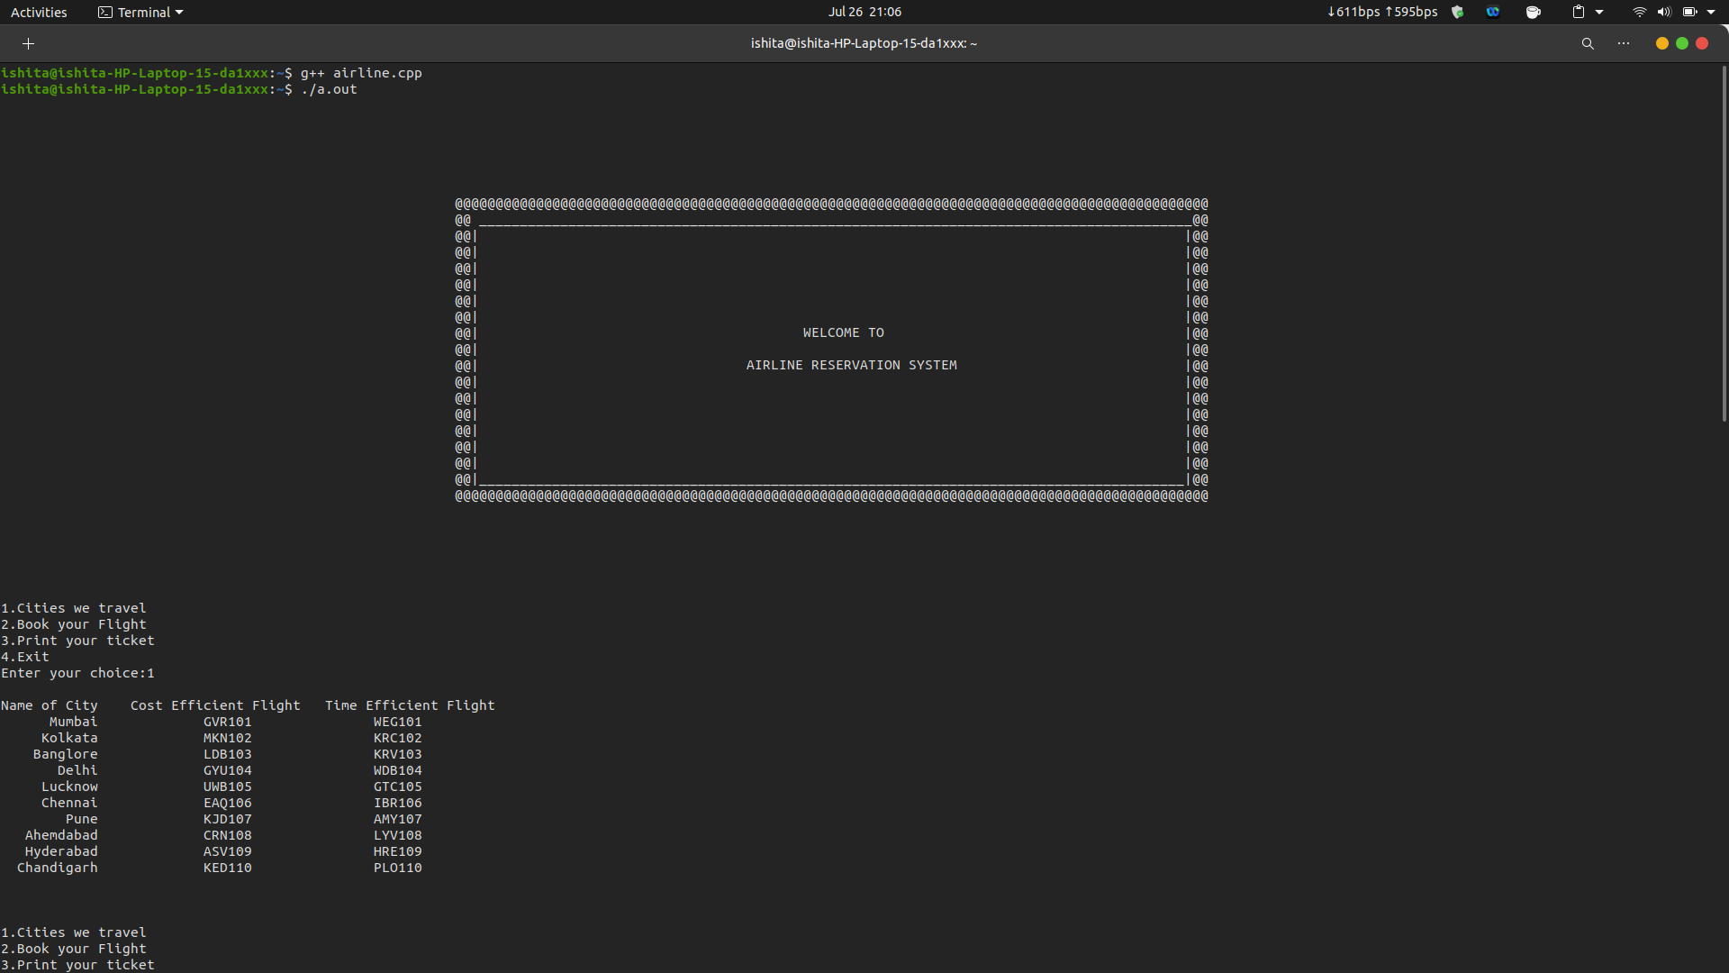
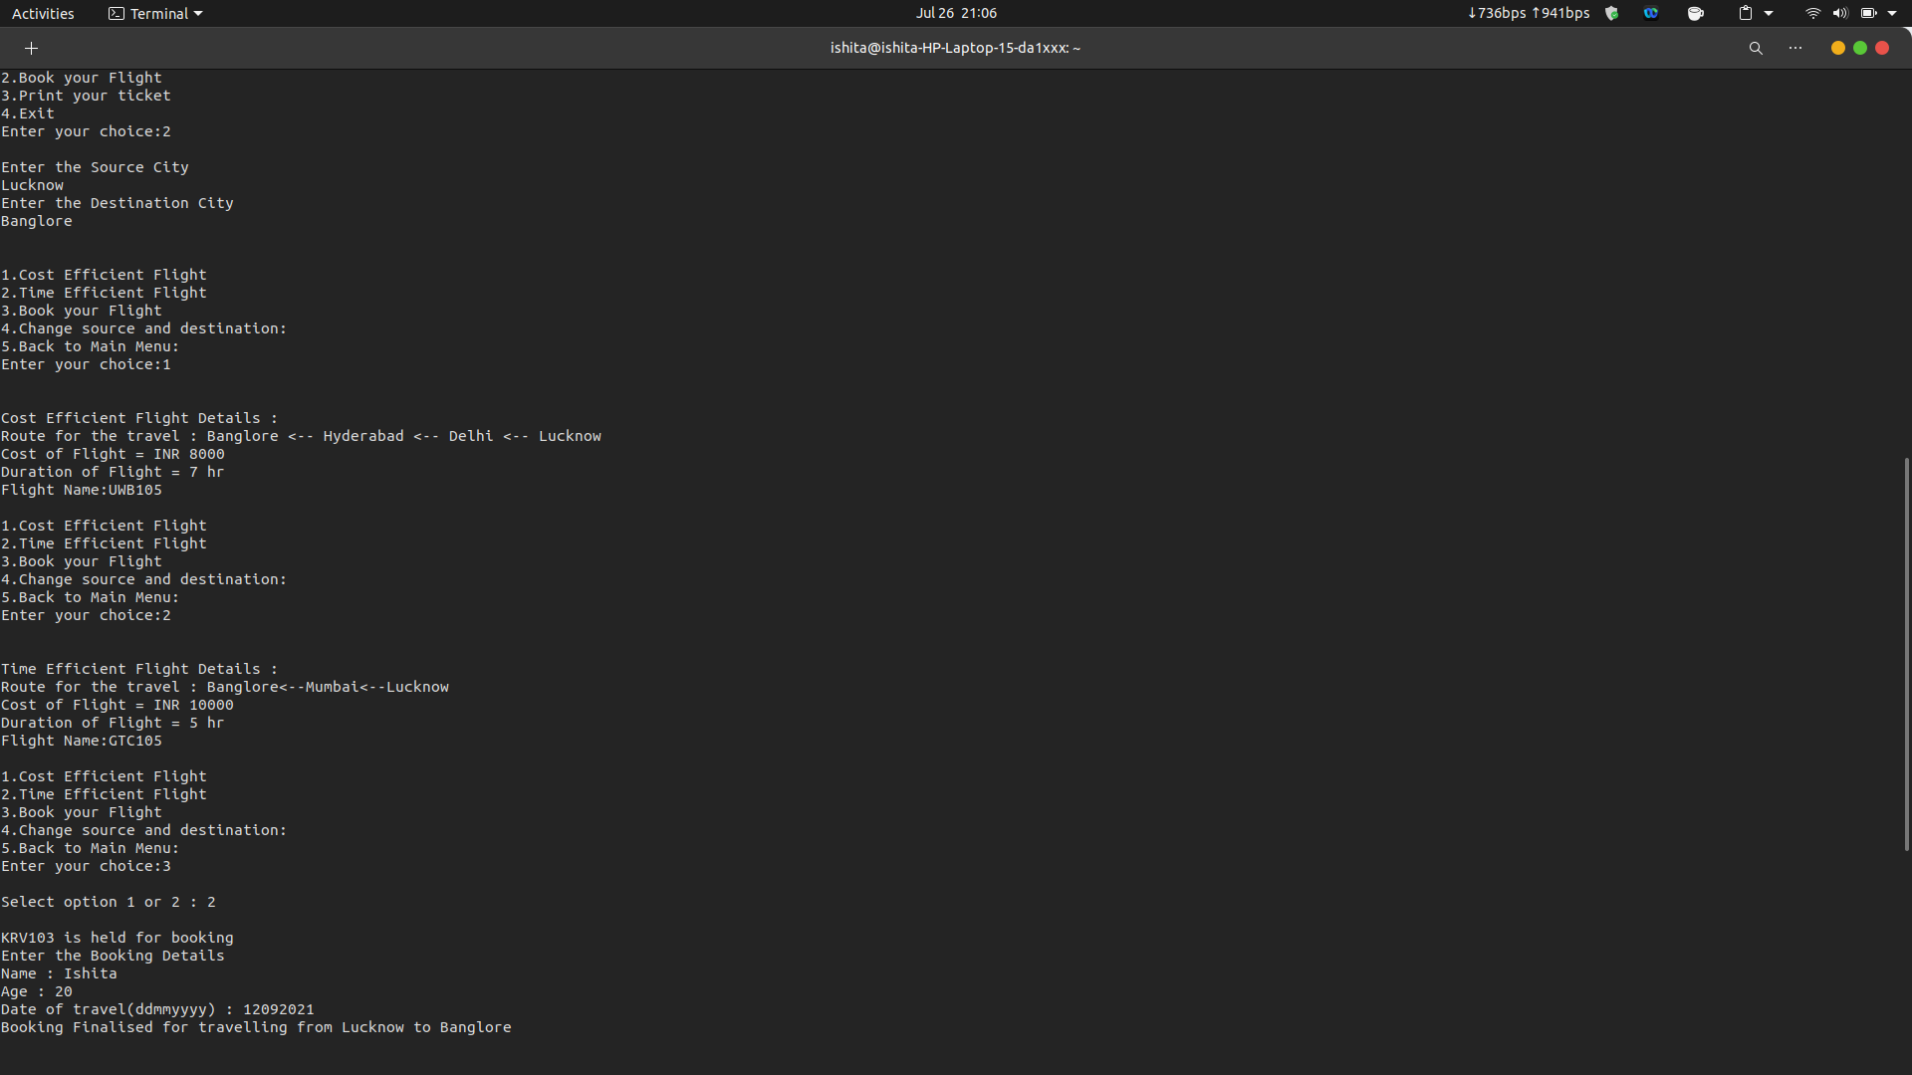

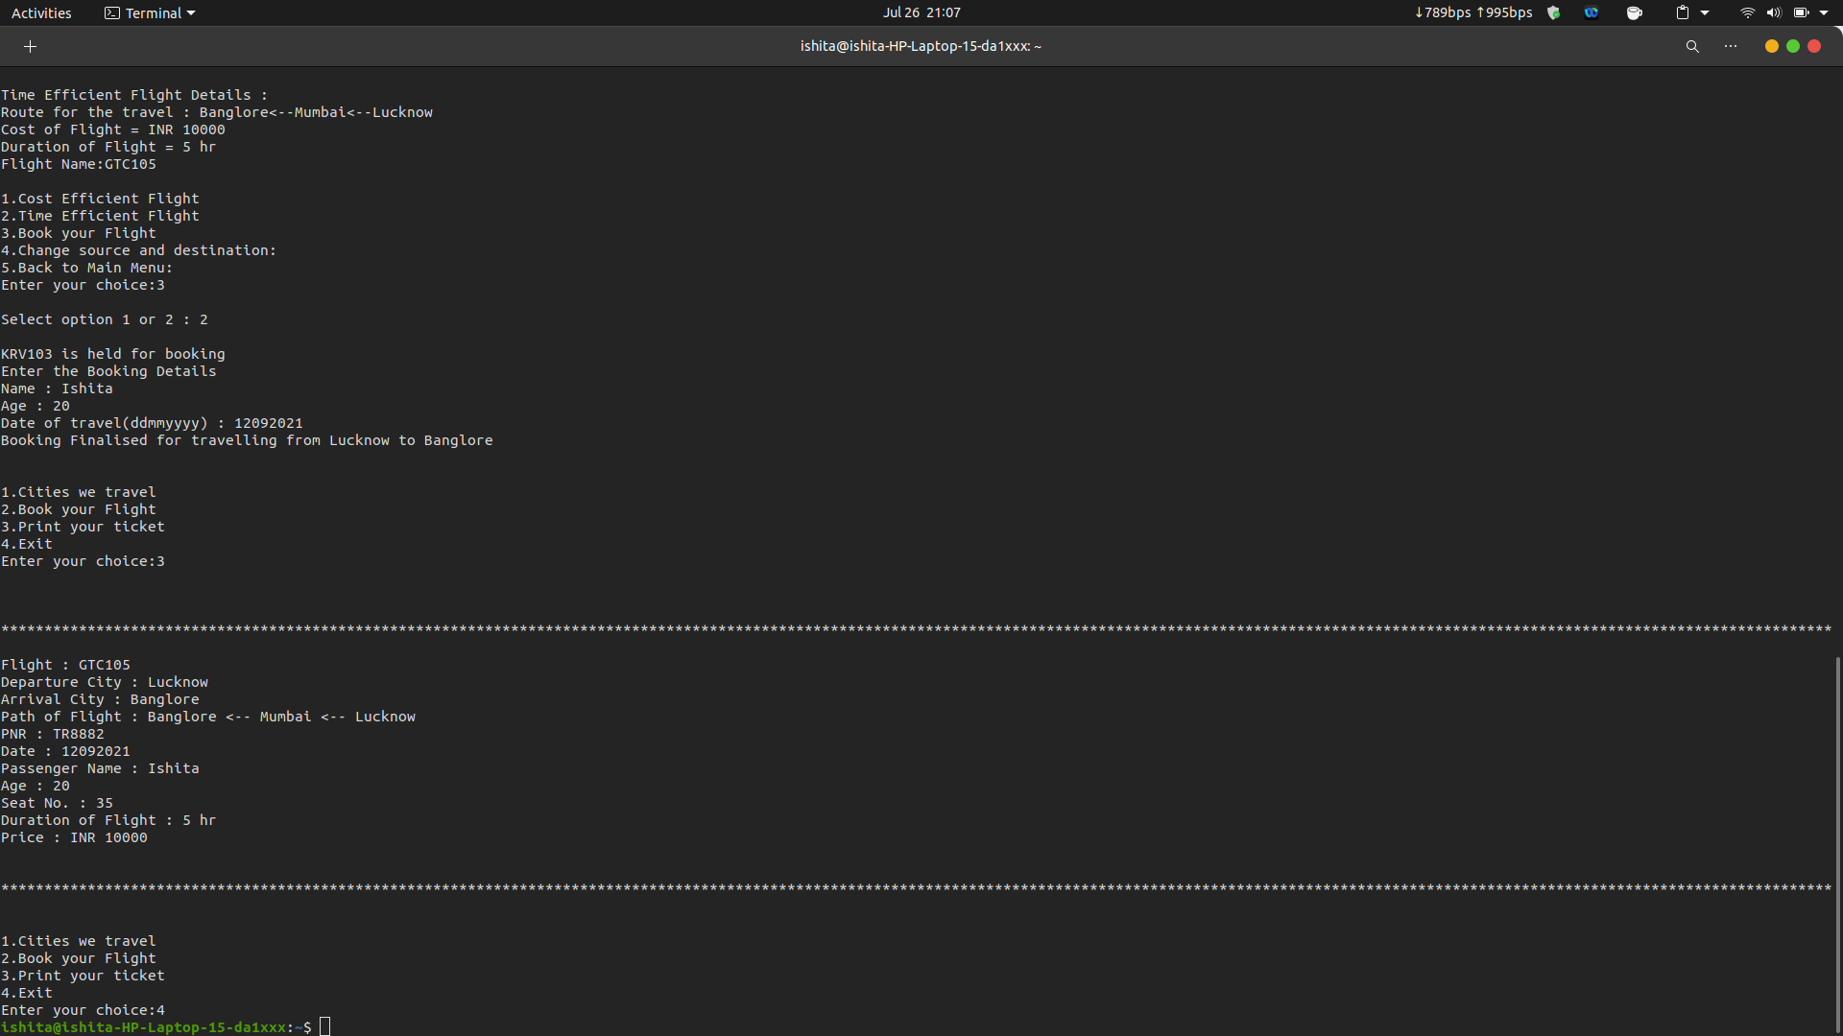

2nd Booking:

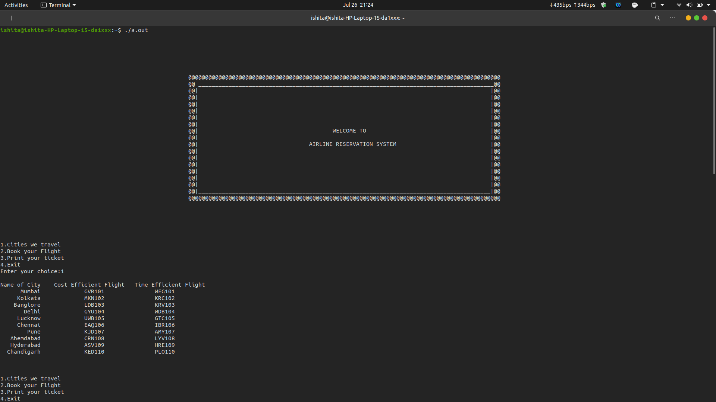

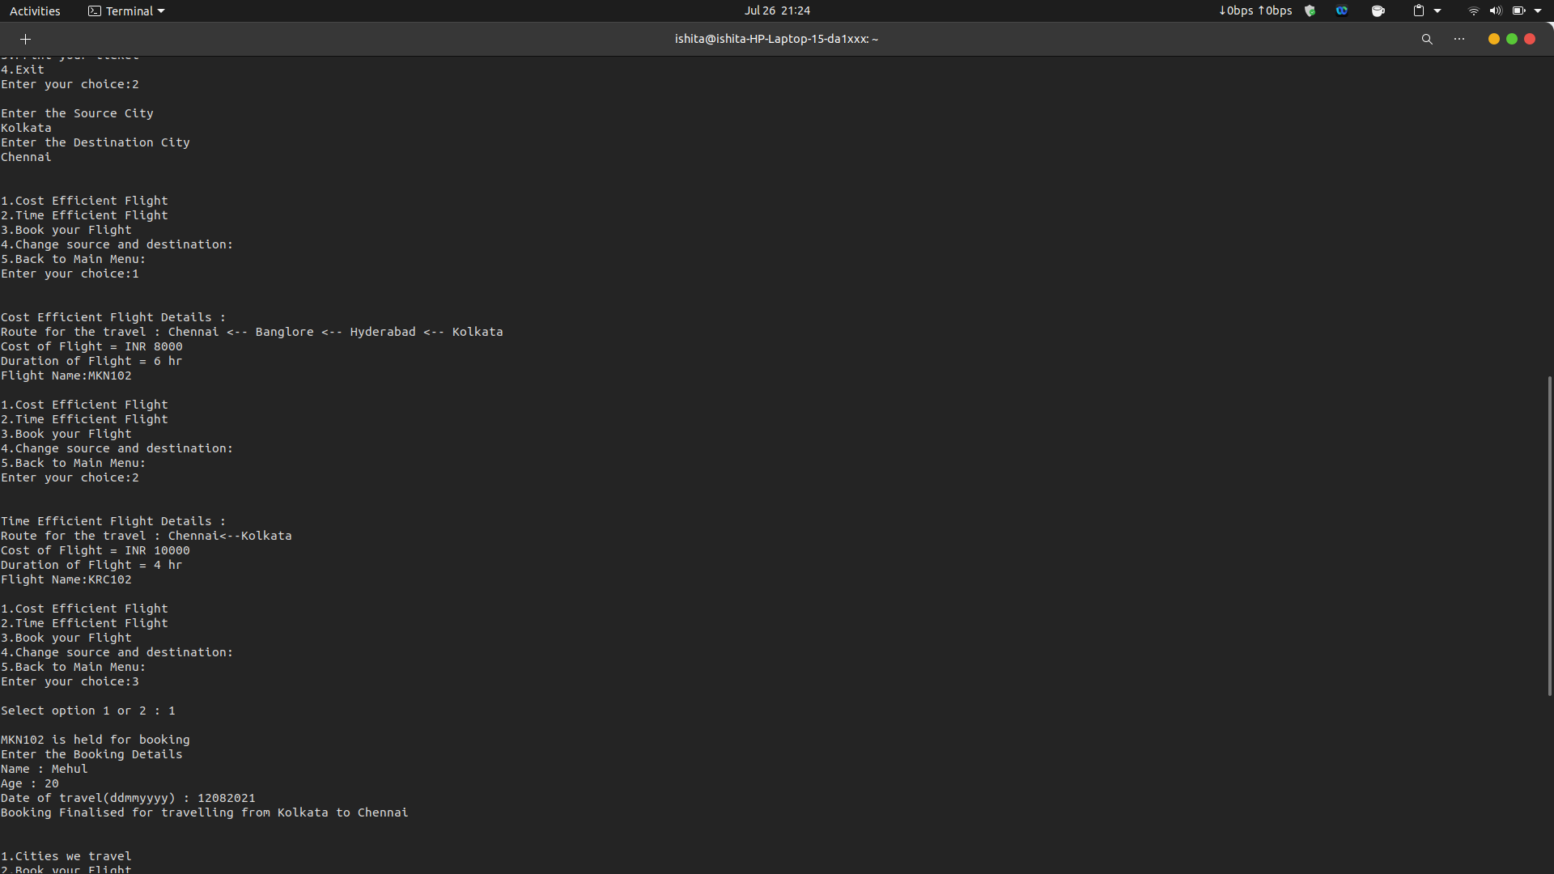

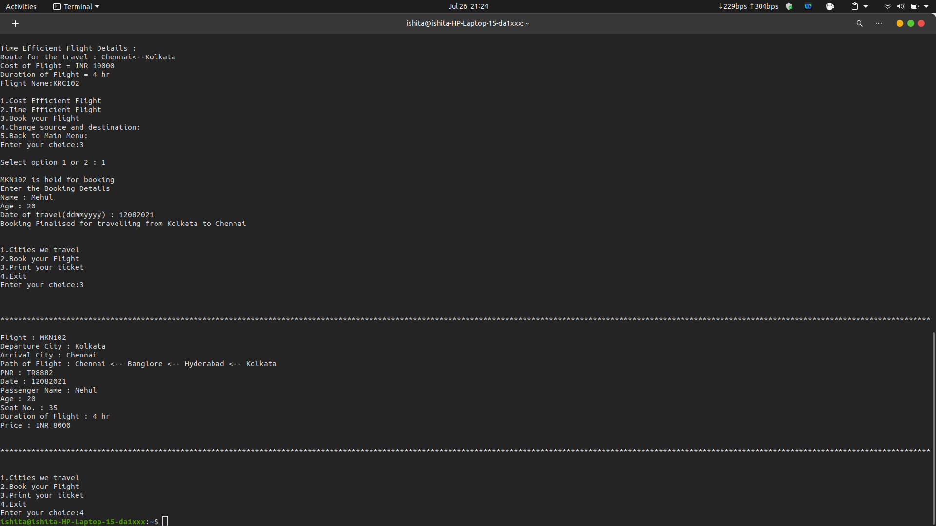

Conclusion:

We attempted to develop a program that reduces the task of the user to find the best flight according to their prefrences. It will gives us the best result for the cost efficient flight and the time efficient flight with the path for travel and the duration of flight. It will print the ticket with all flight details and the path of travel. We can apply this algorithm in the Airline System to find the best flight for the customer.

Reference:

- https://www.geeksforgeeks.org/single-source-shortest-path-between-two-cities/
- https://www.techiedelight.com/single-source-shortest-paths-dijkstras-algorithm/
- https://github.com/bossmanflag/Dijkstras-Truck/blob/master/main.c

